**Project Design Phase – I**

**Solution Architecture**

|  |  |
| --- | --- |
| Date | 20 October 2022 |
| Team ID | PNT2022TMID05666 |
| Project Name | Smart Waste Management System For Metropolitan Cities |
| Maximum Marks | 4 Marks |

**Technical Architecture :**

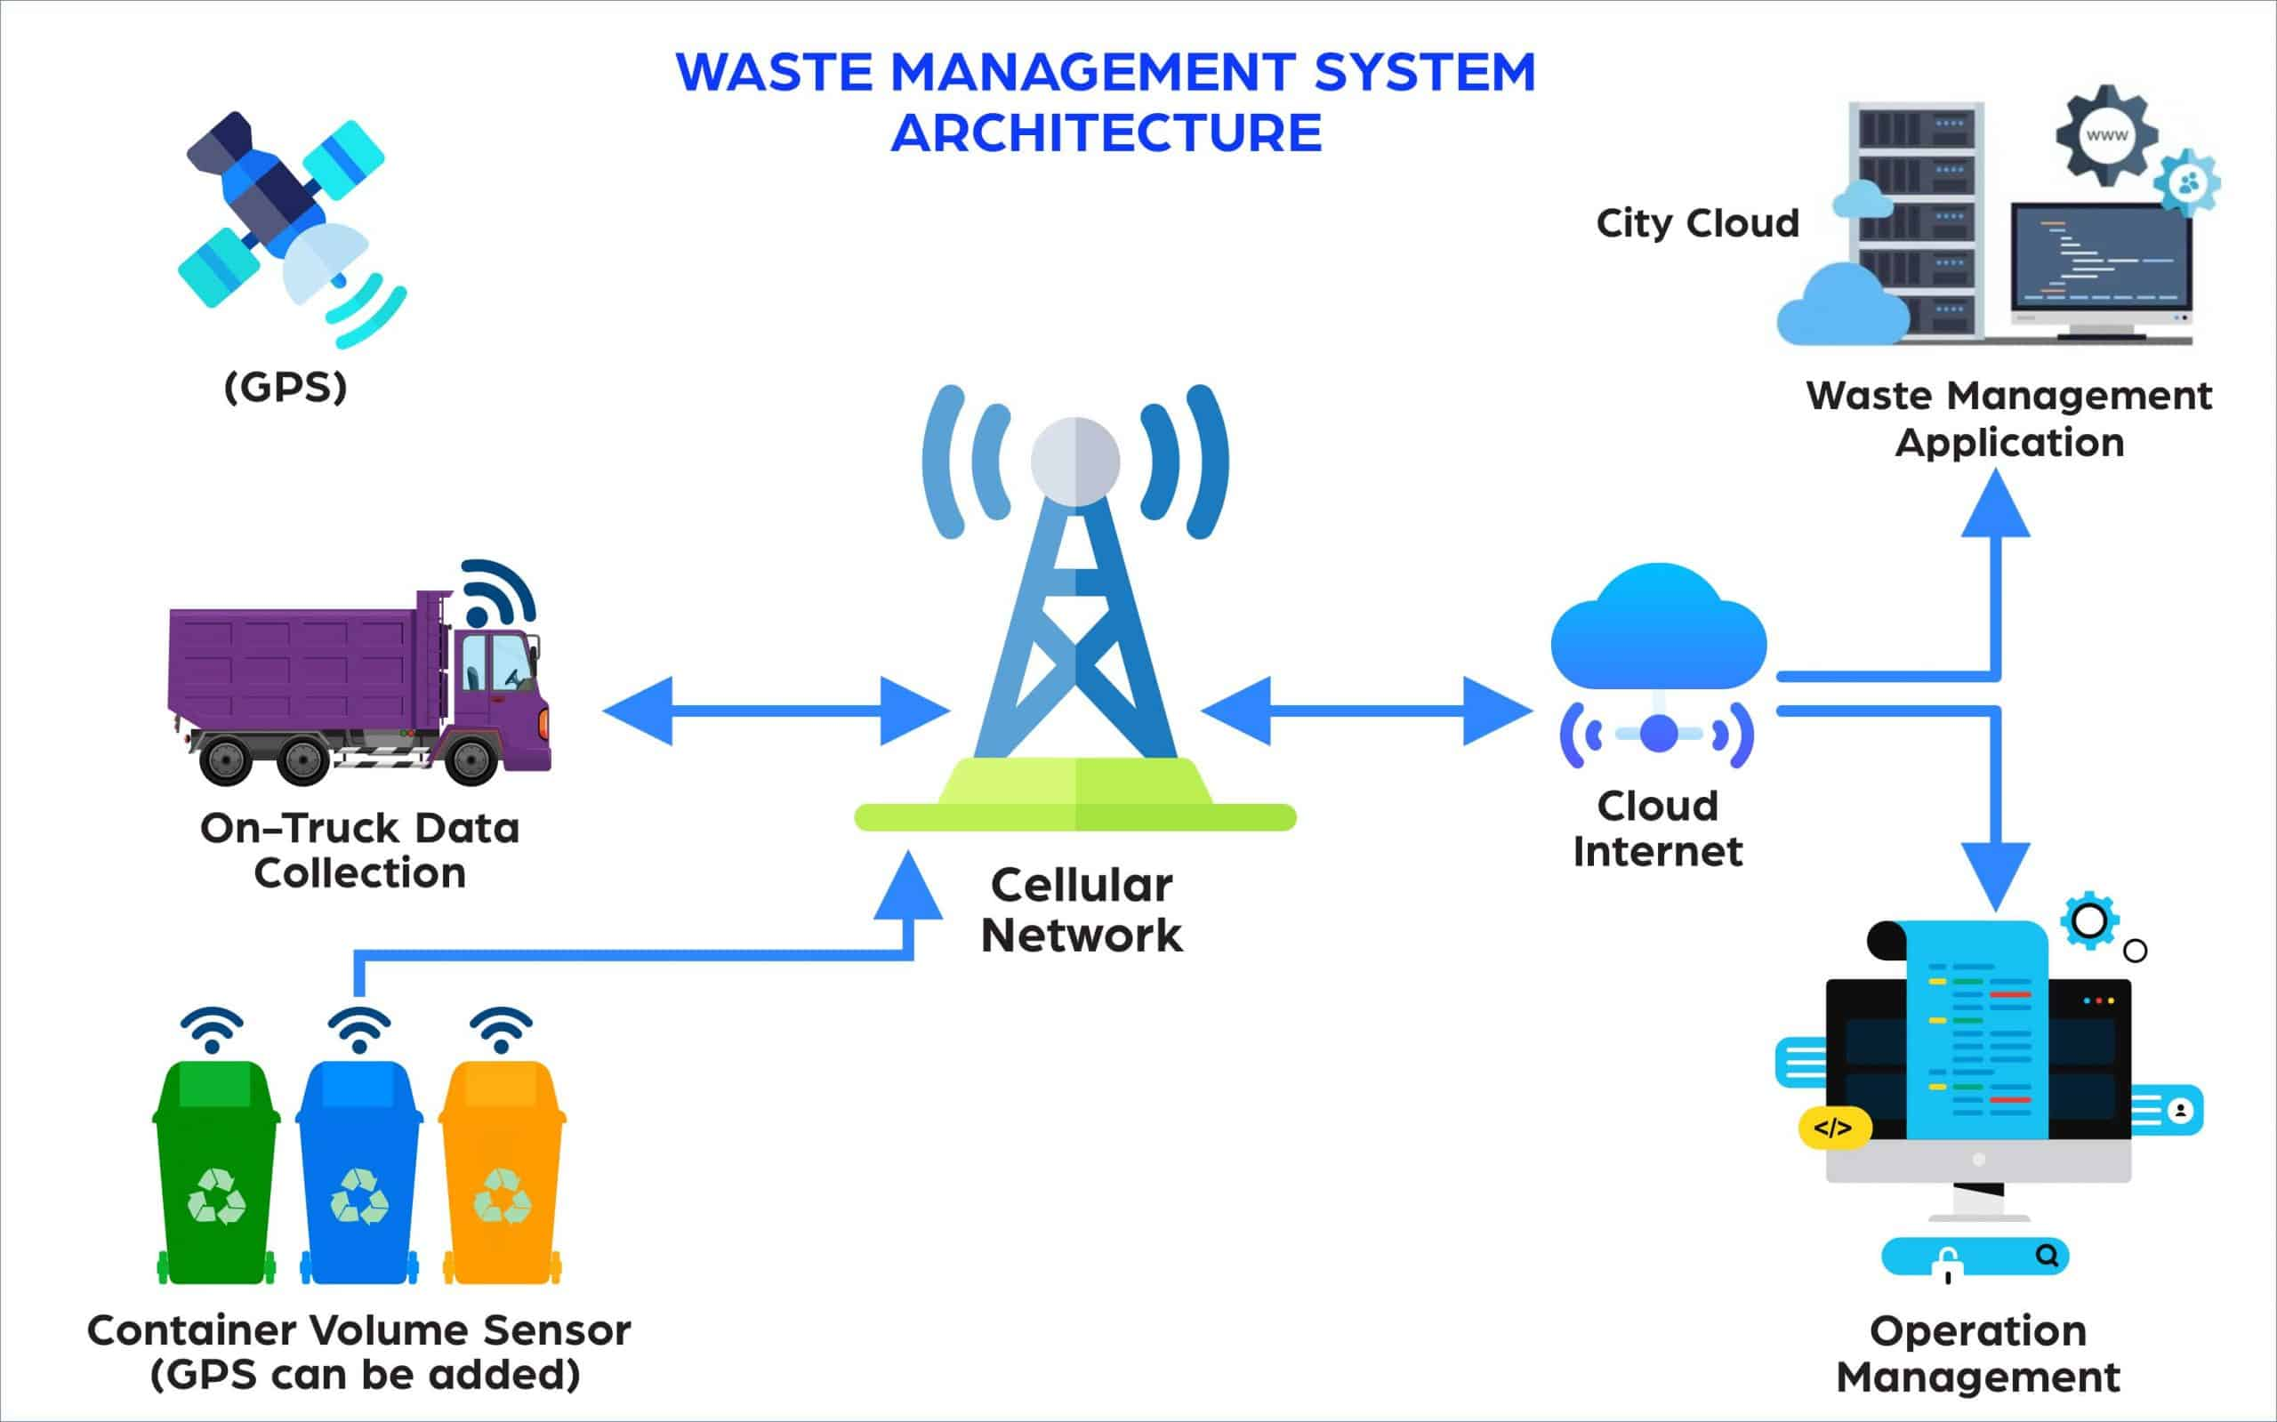

Table 1 : Components & Technologies

|  |  |  |
| --- | --- | --- |
| S.No | Component | Description |
| 1 | Arduino 101 | Arduino 101 combine the ease-of-use of the classic boards with the latest technologies |
| 2 | Ultra Sonic Sensor | an instrument that measures the distance to an object using ultrasonic sound waves. |
| 3 | 9V Battery (Generic) | 9-volt battery, is an electric battery that supplies a nominal voltage of 9 volts |
| 4 | GPS | The Global Positioning System. Provides users with positioning, navigation and timing. |
| 5 | Jumper Wires(Generic) | is an electrical wire, or group of them in a cable, with a connector or pin at each end |
| 6 | LED (Generic) | LED is a semiconductor device that emits light when an electric current flows through it |
| 7 | Arduino IDE | contains a text editor for writing code, a message area, a text console, a toolbar with buttons |
| 8 | Cloud Server | is a pooled, centralized server resource that is hosted and delivered over a network—typically the Internet |
| 9 | Blynk | Blynk is an IoT platform for iOS or Android smartphones that is used to control Arduino |

Table 2 :Application charasteristics:

|  |  |  |
| --- | --- | --- |
| S.no | Characteristics | Description |
| 1 | Open Source Microcontroller | Arduino Uno is used to make IOT Devices |
| 2 | Security | Encryption/Decryption is used for security purpose |
| 3 | Scalable Architecture | New features can be added |
| 4 | Availability | Web applications can be accessed from anywhere |
| 5 | Performance | All truck drivers can access the application at same time |